1. Check if A = …(B)

|  |  |  |  |  |  |  |
| --- | --- | --- | --- | --- | --- | --- |
| **A** | **B** | **O** | **o** | **Ω** | **ω** | **Θ** |
| **logkn** | **ne** | Yes | Yes | No | No | No |
| **nk** | **cn** | Yes | Yes | No | No | No |
| **n1/2** | **nsin n** | No | No | No | No | No |
| **2n** | **2n/2** | No | No | Yes | Yes | No |
| **nlgc** | **clgn** | Yes | No | Yes | No | Yes |
| **lg(n!)** | **lg(nn)** | Yes | No | Yes | No | Yes |

1. (I added pictures of my solutions.)

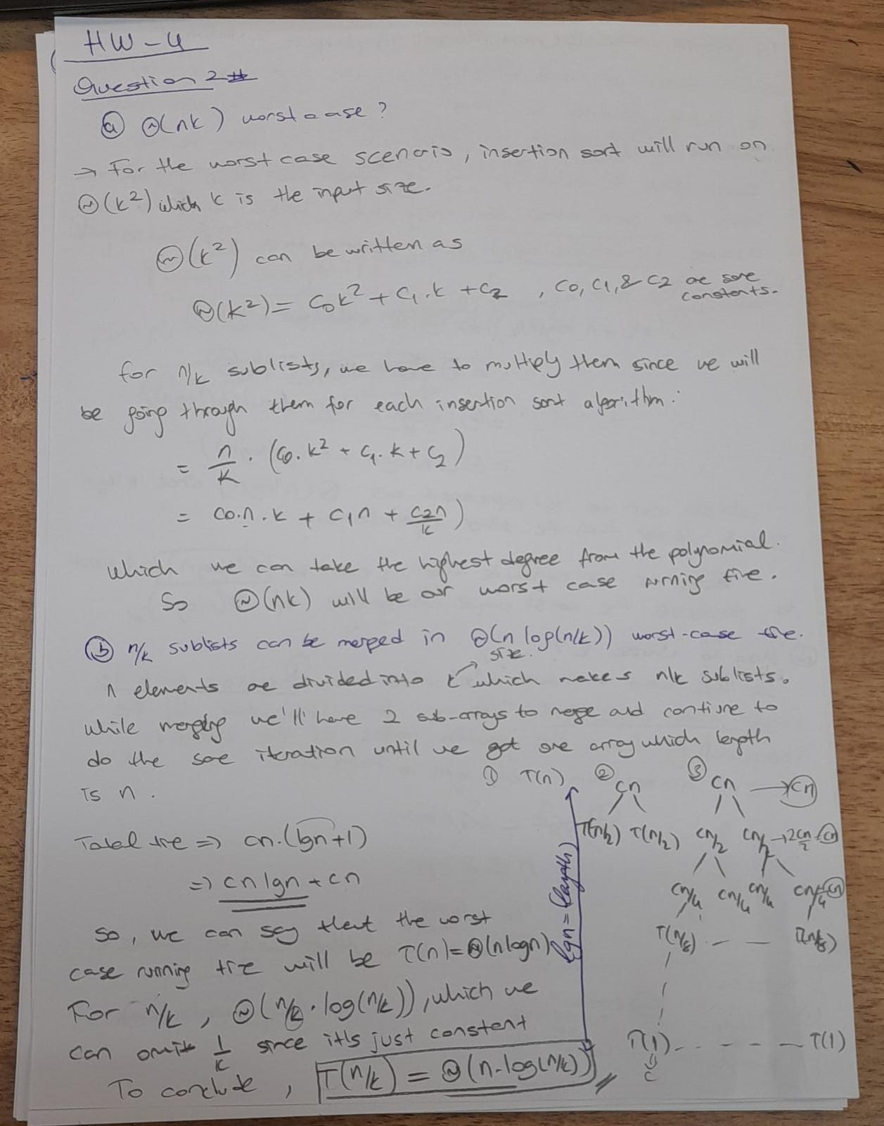

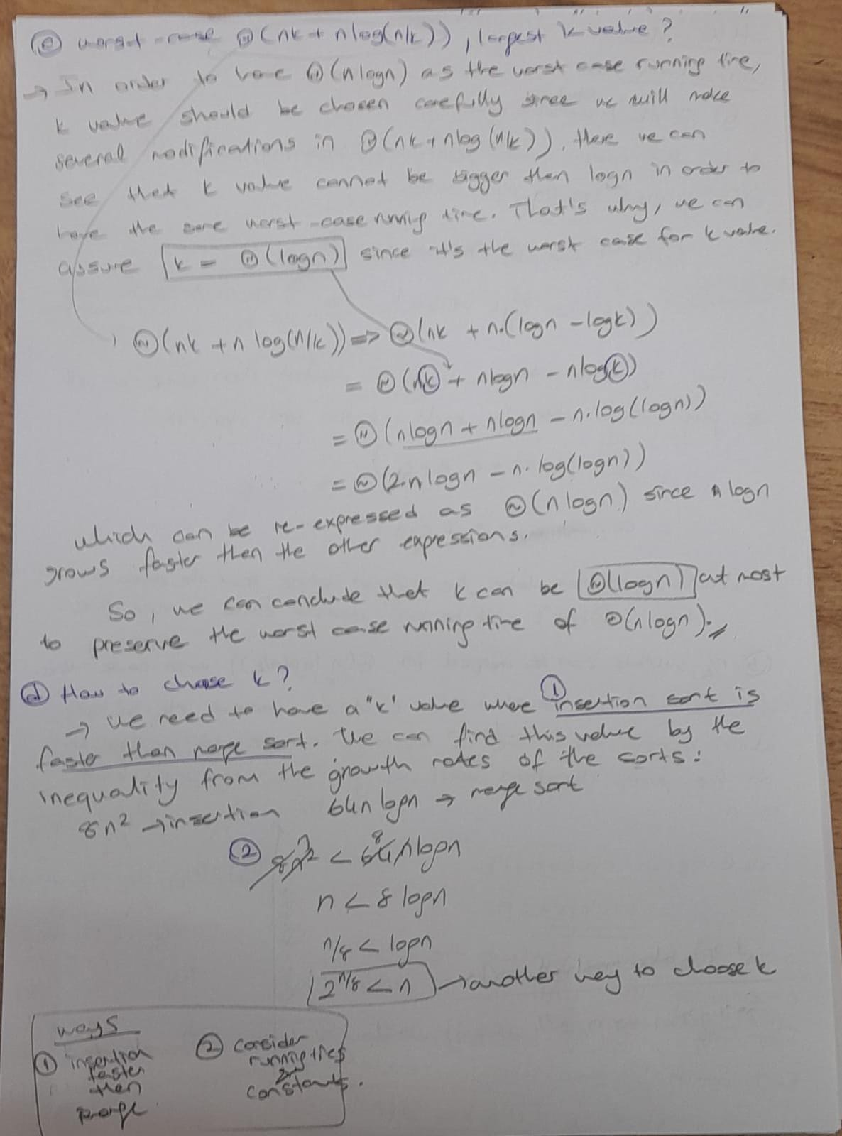

1. (I added my solution.)

